**Wireframe Documentation**

**ANALYZING AMAZON SALES DATA**

**GAUTAM VORA**

**1: Info**

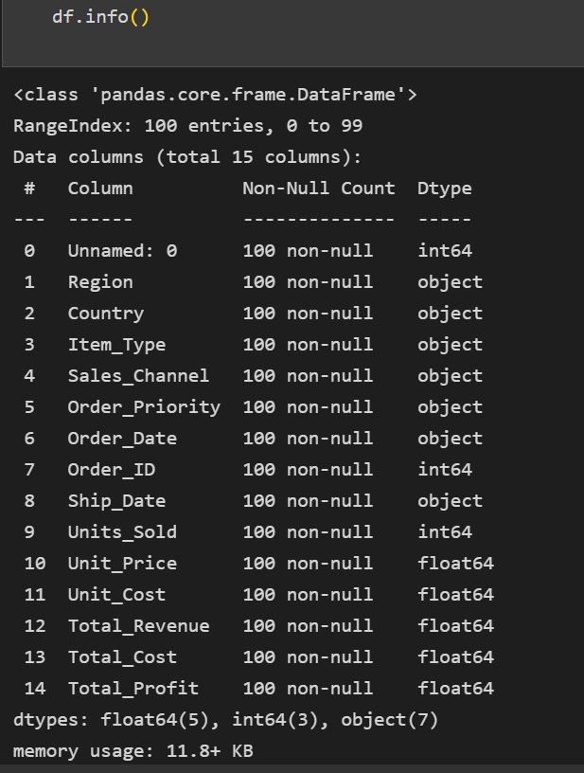

**2: Distribution of Item Type**

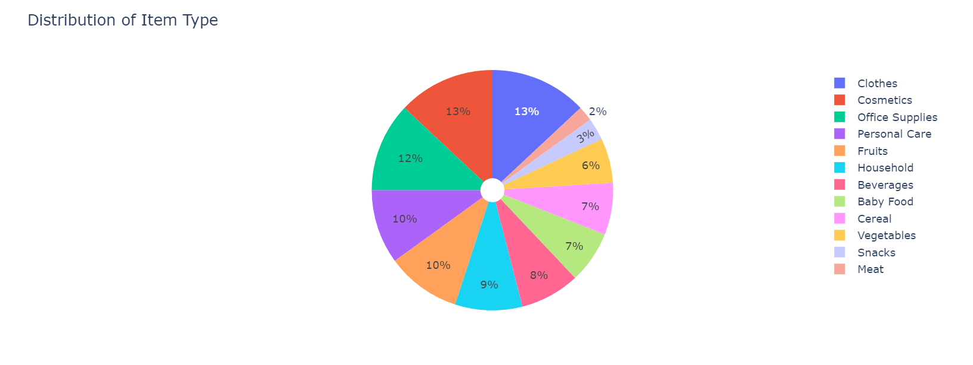

**3: Which item is best for Profit**

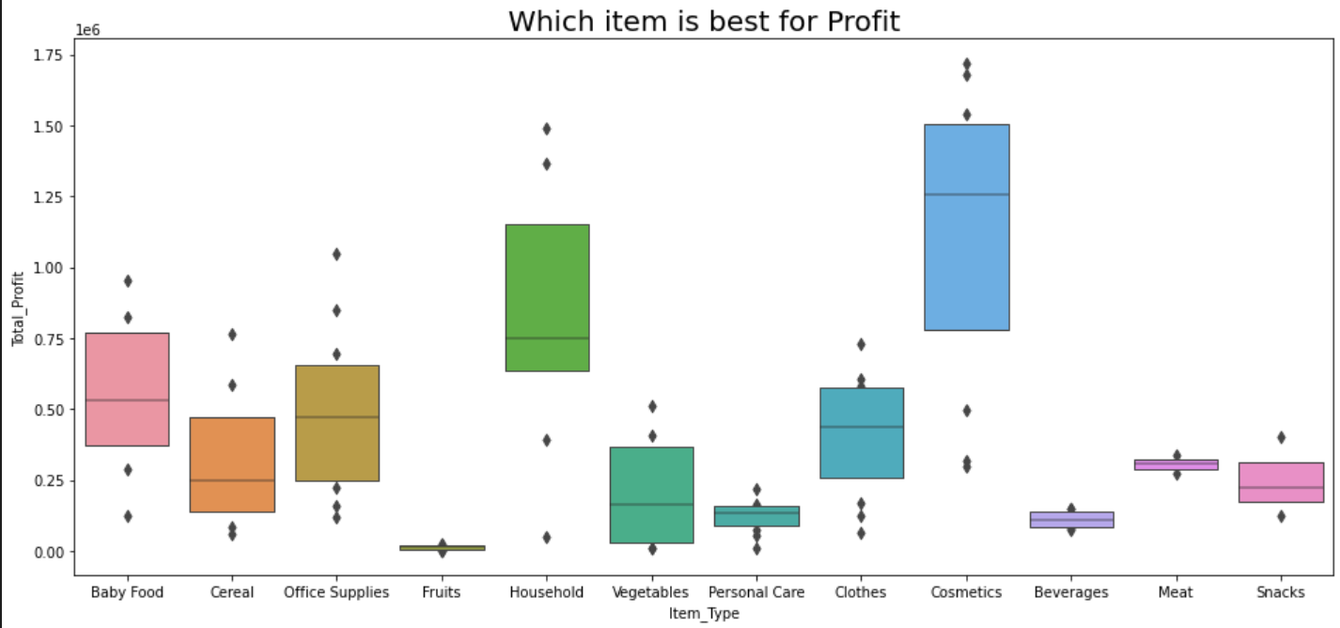

**4. which item is less Costly**

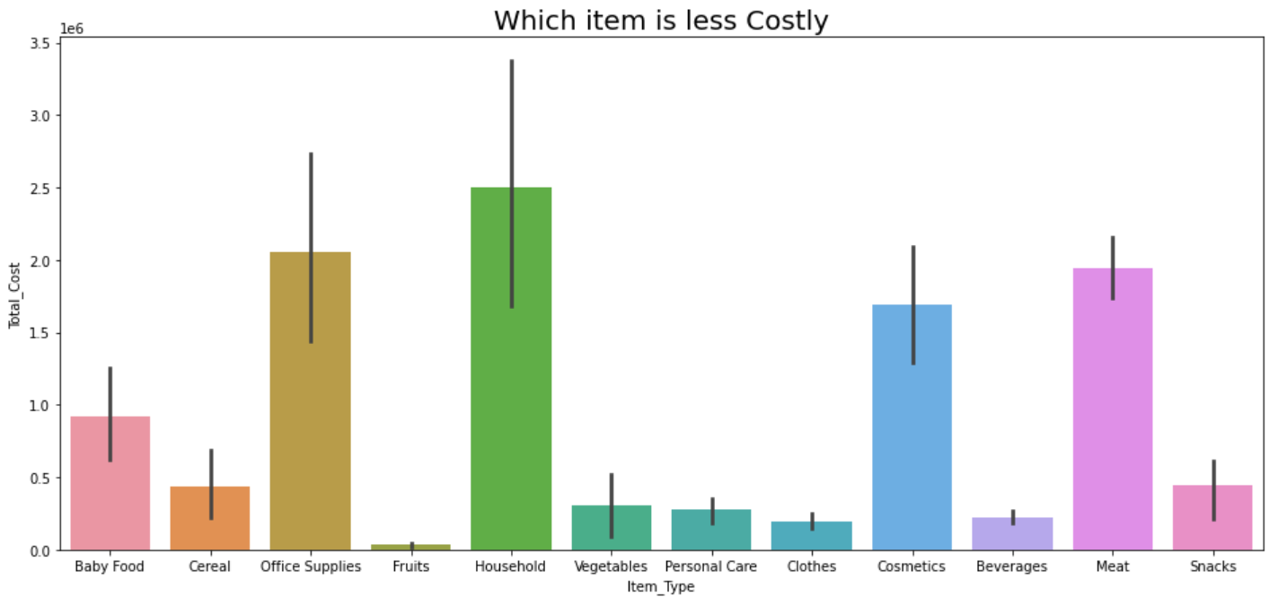

**5. which Sales Channel is best for the Profit**

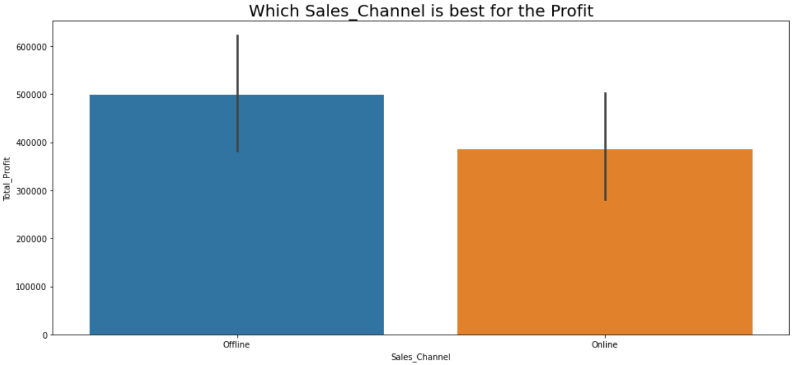

**6. Total Profit country wise**

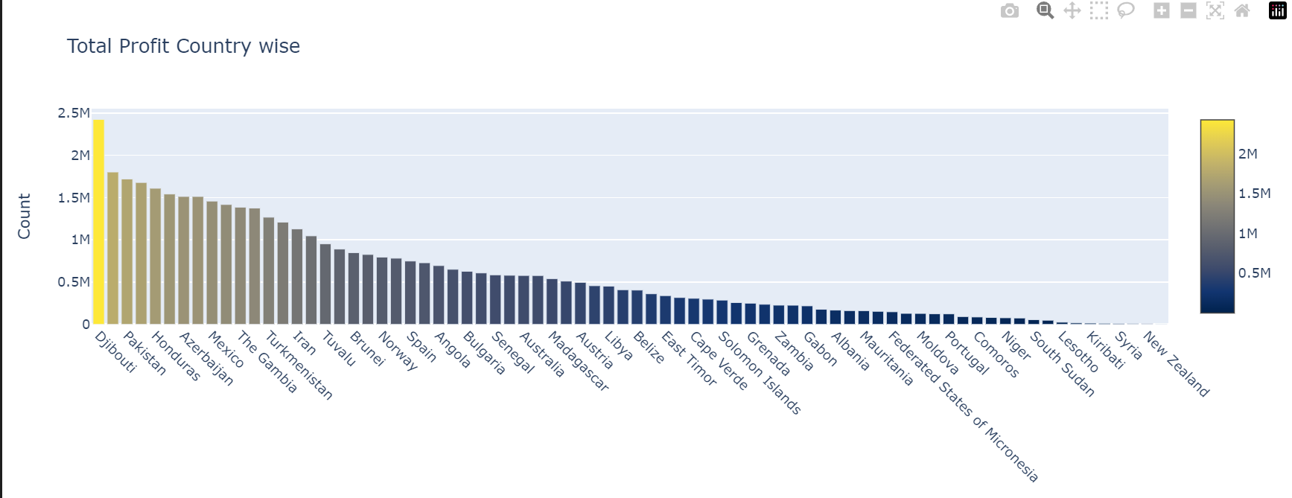

**7.Daily orders**

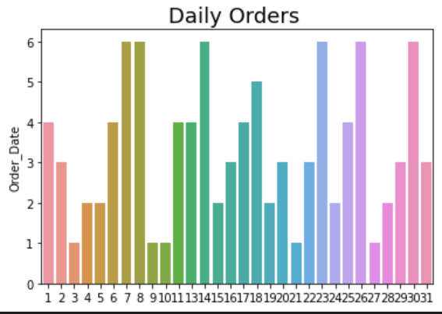

**8.Monthly Orders**

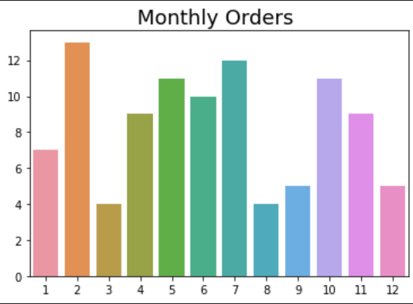

**9.Yearly orders**

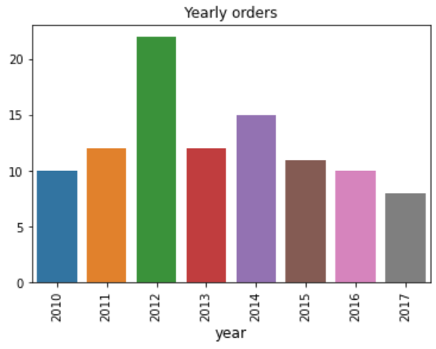

**10. Monthly Sales Trends :-**

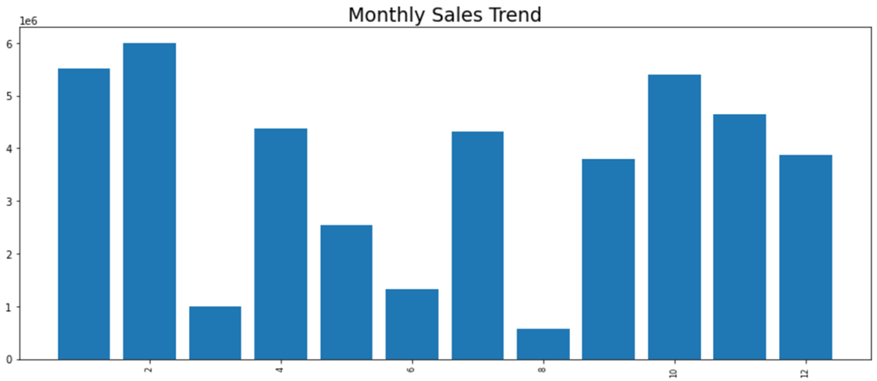

**11. Yearly Sales Trend**

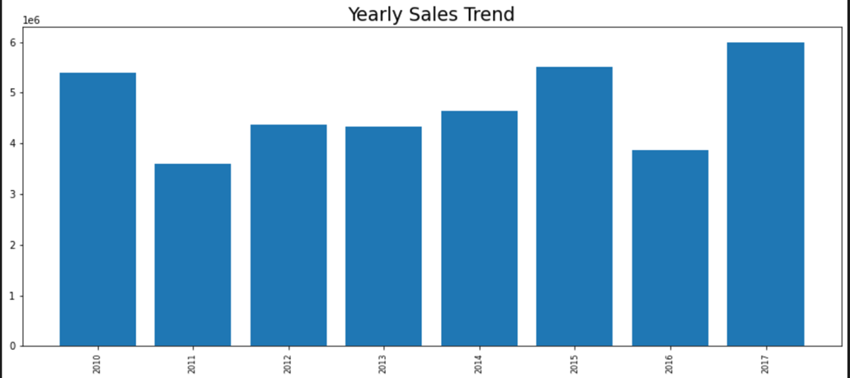

**12. Yearly Month-Wise Sales Trend**

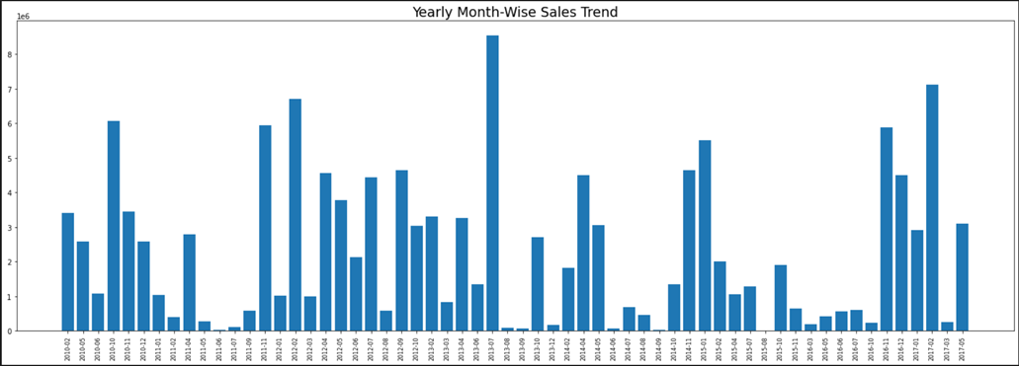

**13. Total Revenue**

